How can you quantify the impacts of the proposed agricultural element on the hydrologic system 100 years into the future?

From our head profiles at each of our observation wells and the towns pumping well we can find that the addition of agriculture will lead to decreseased head across the board and will continue to drop even after the 100 year period.

How do these impacts compare with the impacts of the town's pumping?

Towns pumping seems to decrease head gradually if you look at figures 1, 2 &3 the first 100 years represents head from just town pumping and if continued by itself would yield much higher head values at the end of the model time than with agriculture.

How will the agricultural element affect the town's ability to meet its water demand (both for quantity and quality?) Describe your metrics as precisely as you can and quantify the impact(s).

If this downward trend continues at a constant rate it will be much harder for the town to get water as they will have to dig wells deeper into the earth. The availability of clean drinking water may be hindered because the towns well is directly down head gradient from the agriculture recharge zone (Figure 4) and the increased pumping will have a further reach of where water comes from. To limit contamination, it would be ideal to have the agriculture zone down head gradient from the towns pumping well or across the river.

Figure 1:

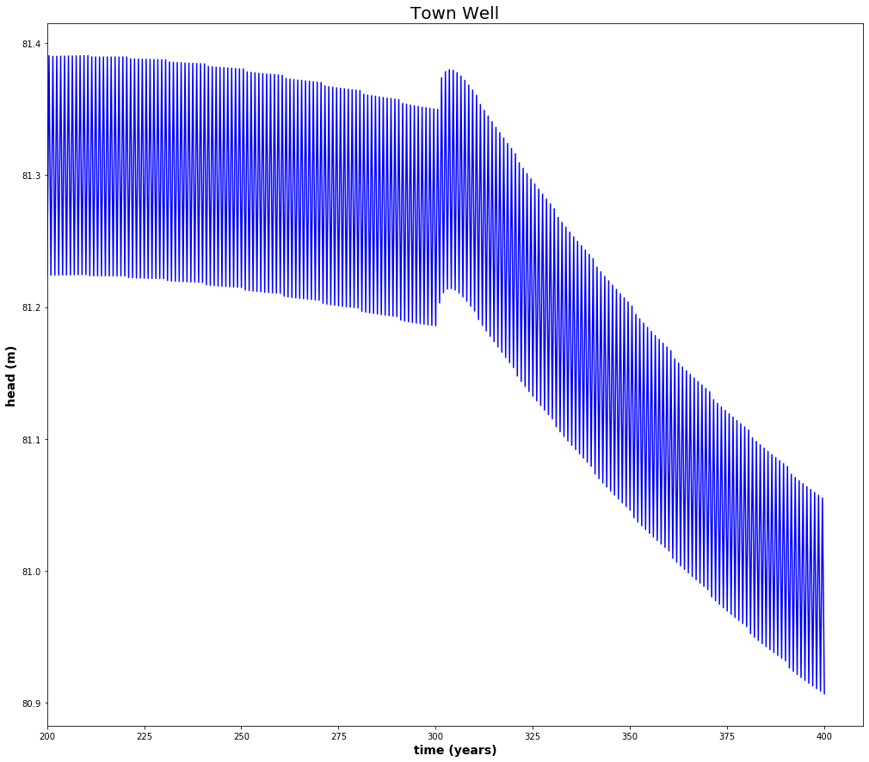

Figure 2:

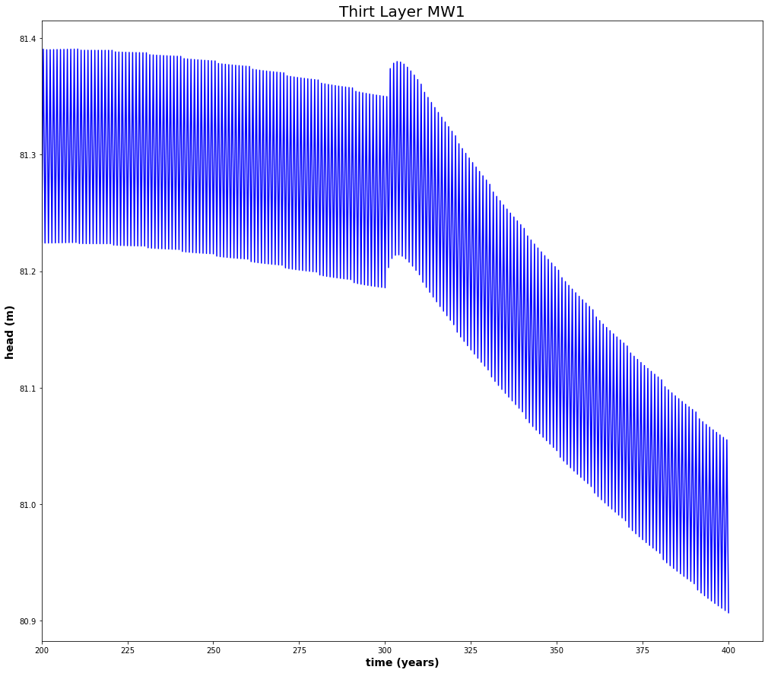

Figure 3:

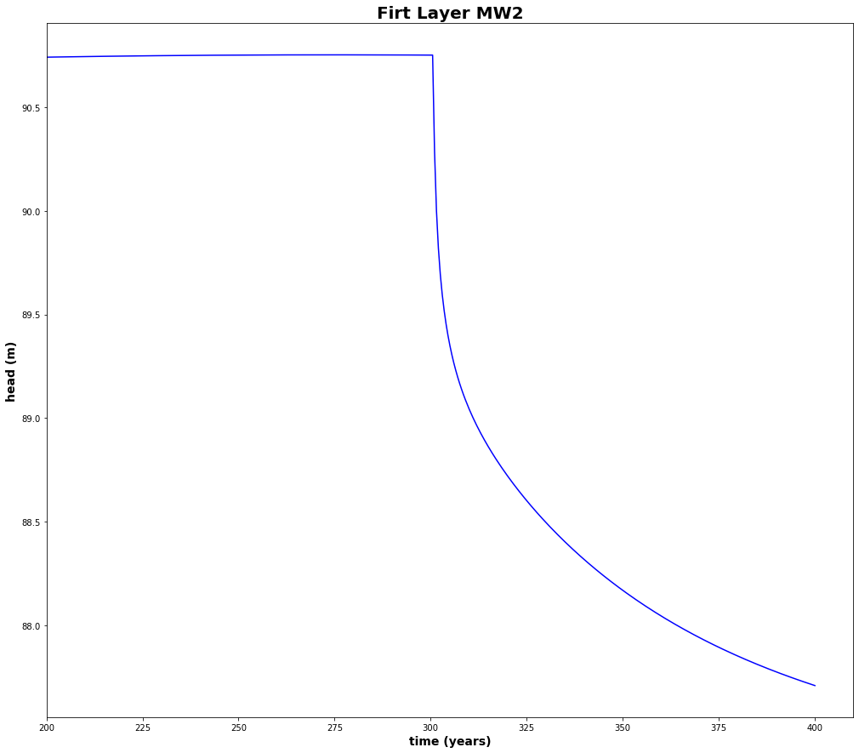

Figure 4: Head profile of last time step of town well Agriculture recharge zone is in columns 19 & 20 of this figure